**DB Lab 01**

**Name:** Hafsa Salman

**Roll no.** 22K-5161

**Logical Operators Question 01**

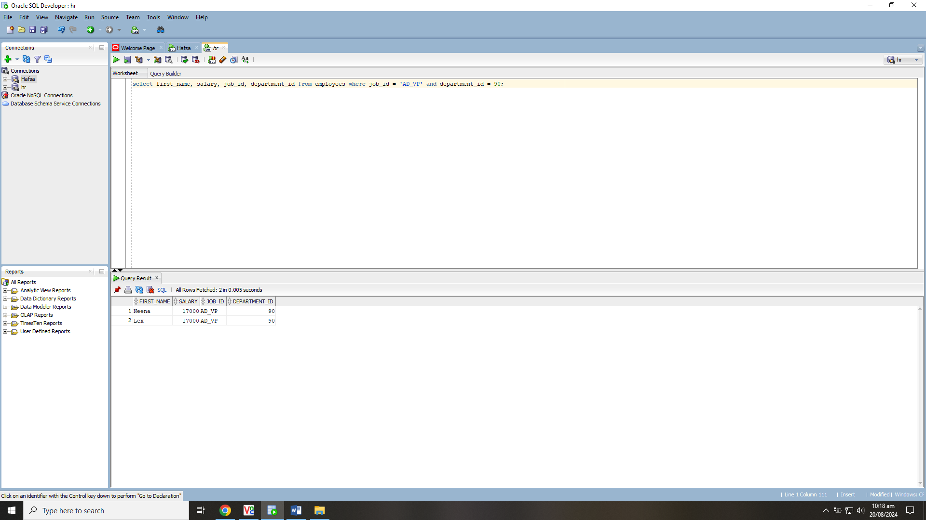

**Logical Operators Question 02**

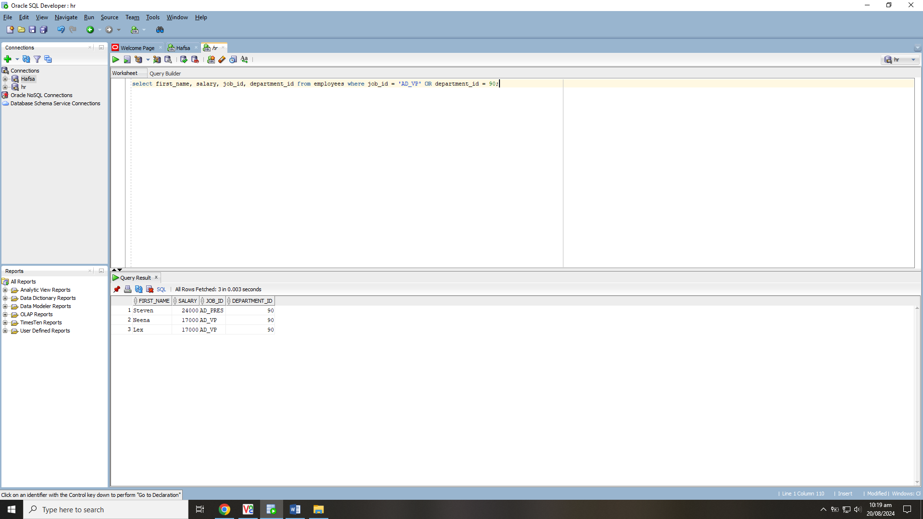

**Logical Operators Question 03**

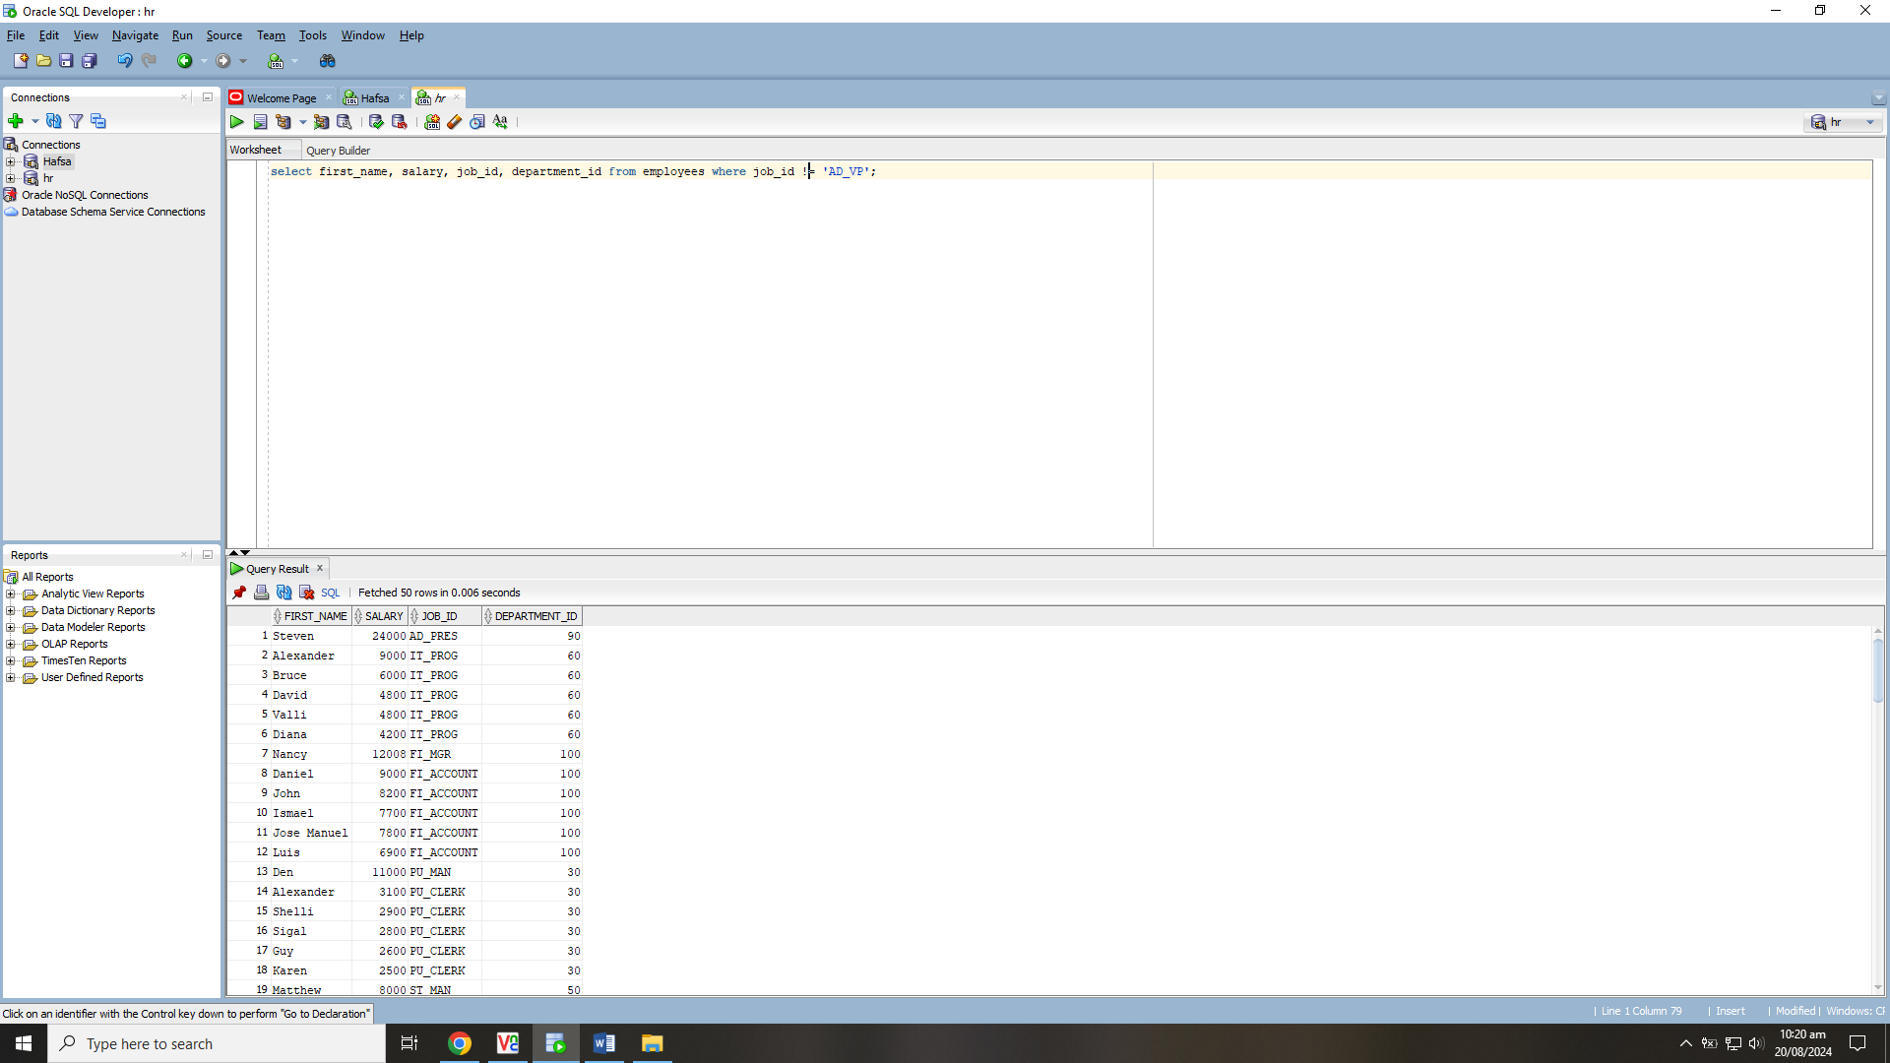

**Task no. 01**

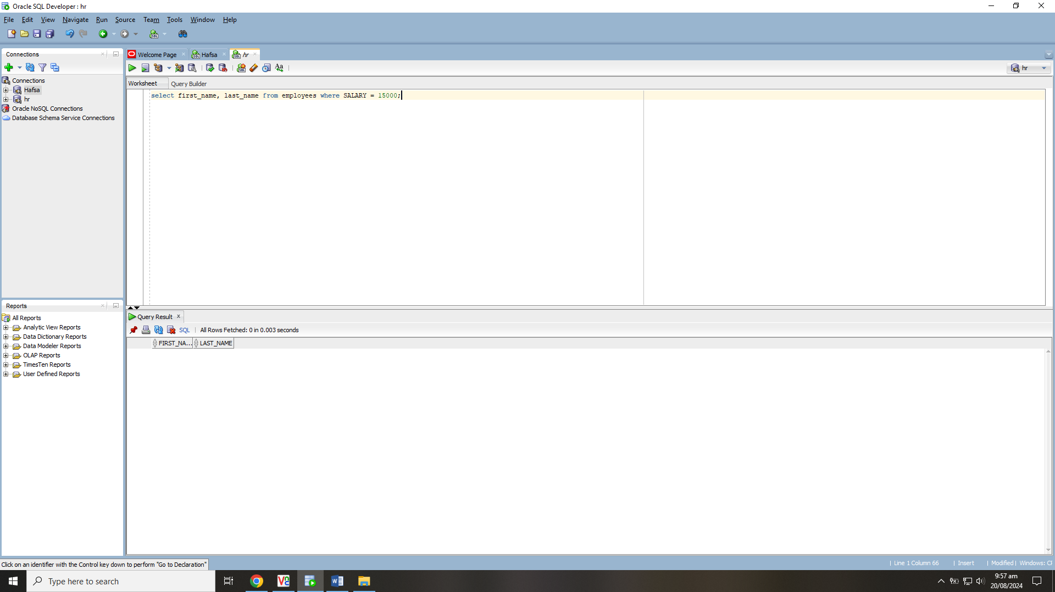

**Task no. 02**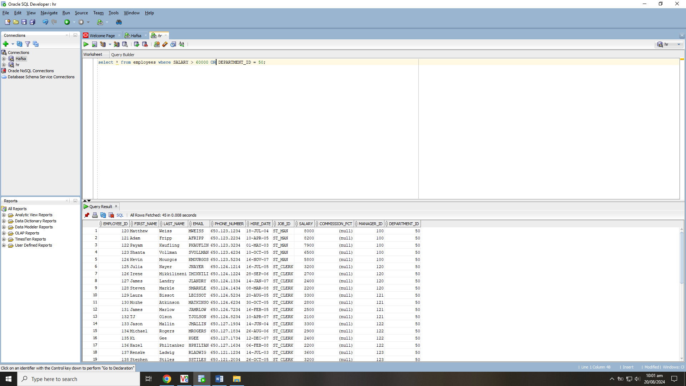

**Task no. 03**

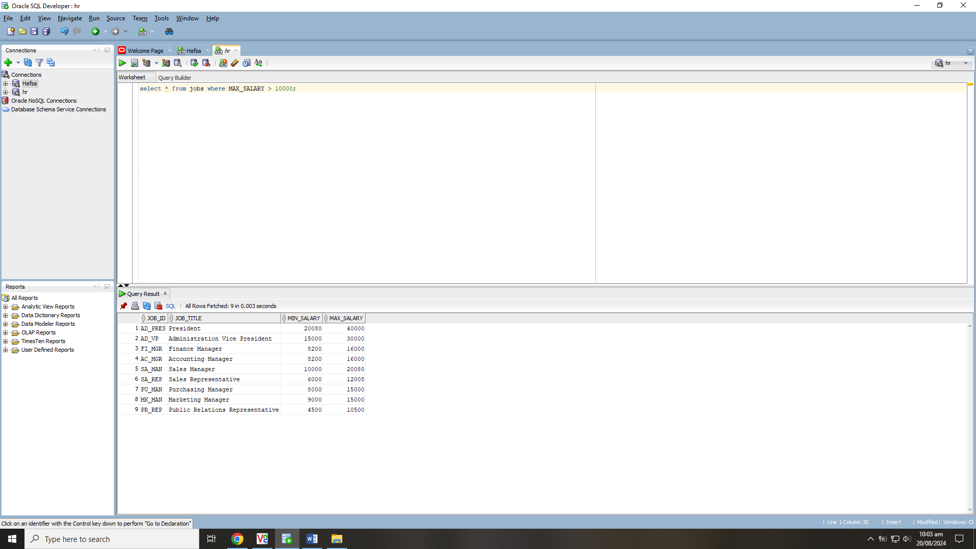

**Task no. 04**

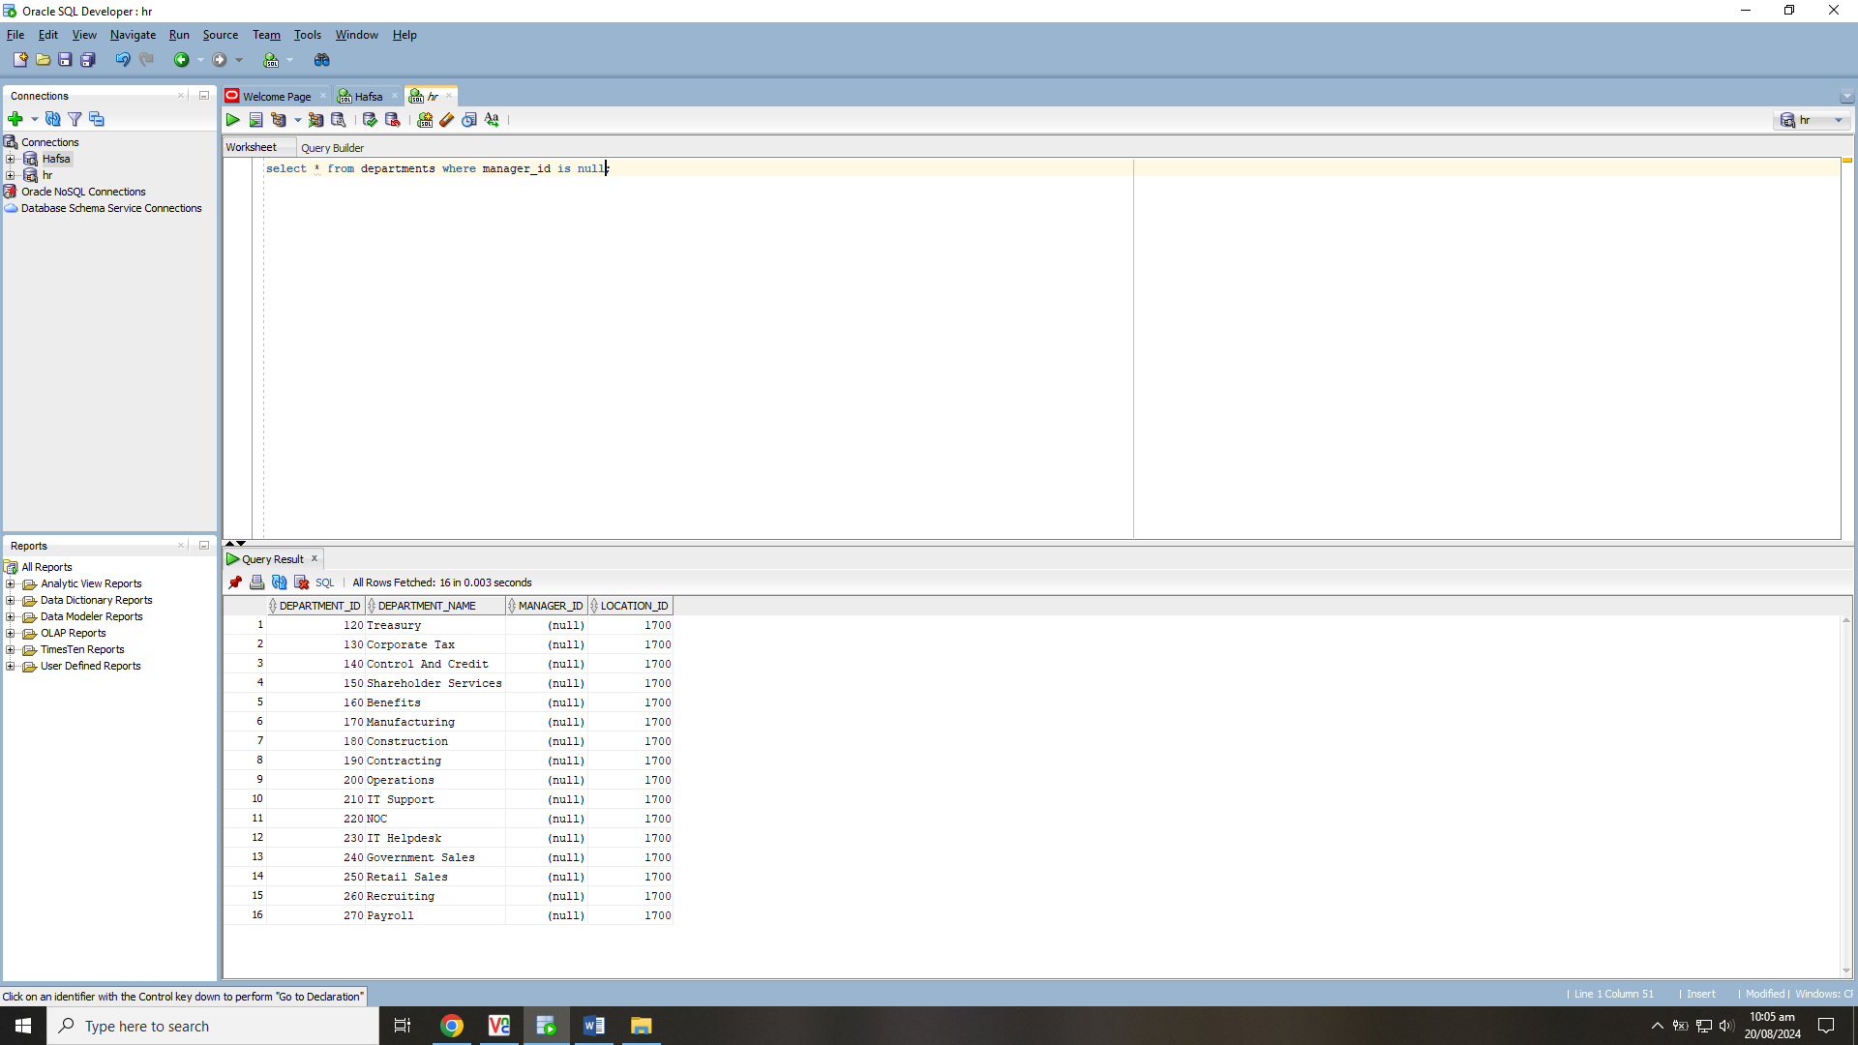

**Task no. 05**

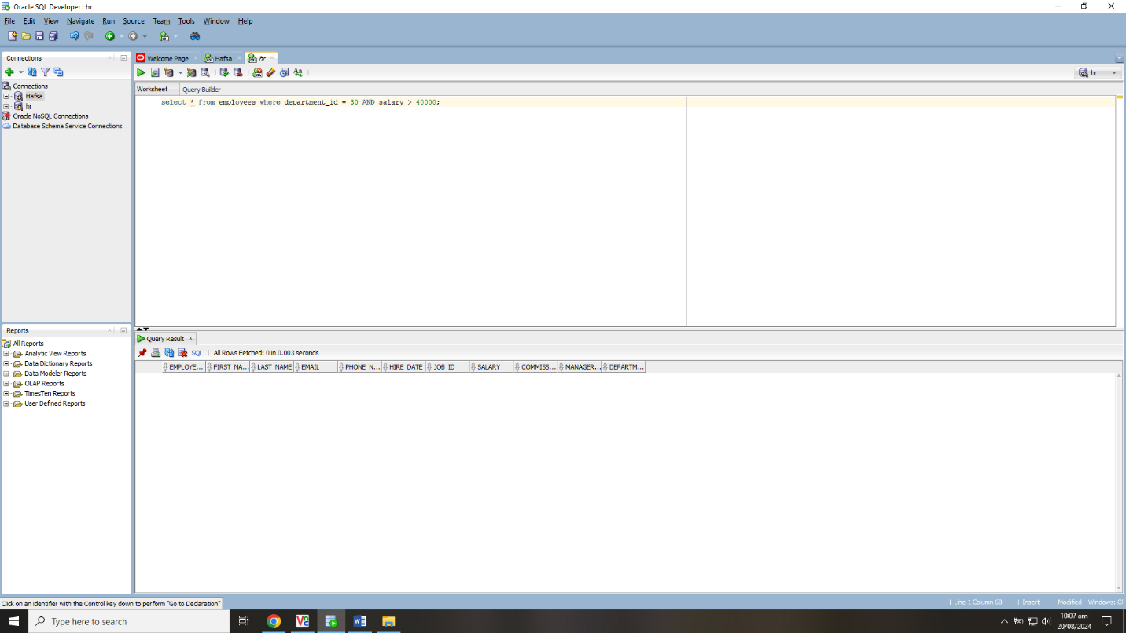

**Task no. 06**

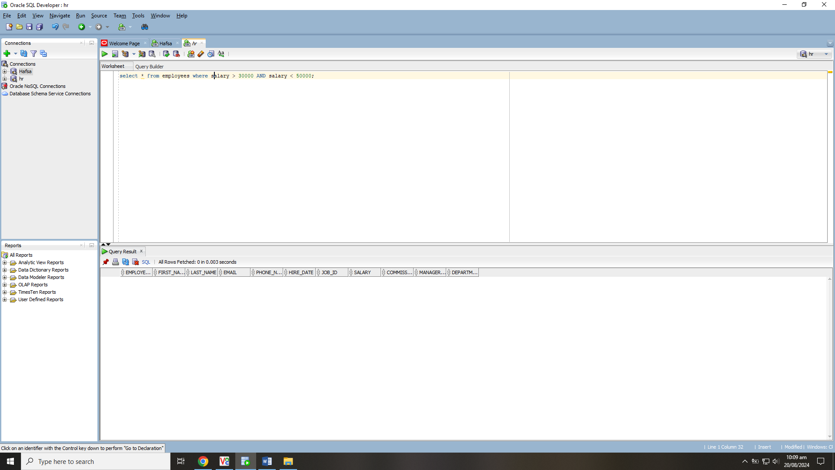

**Task no. 07**

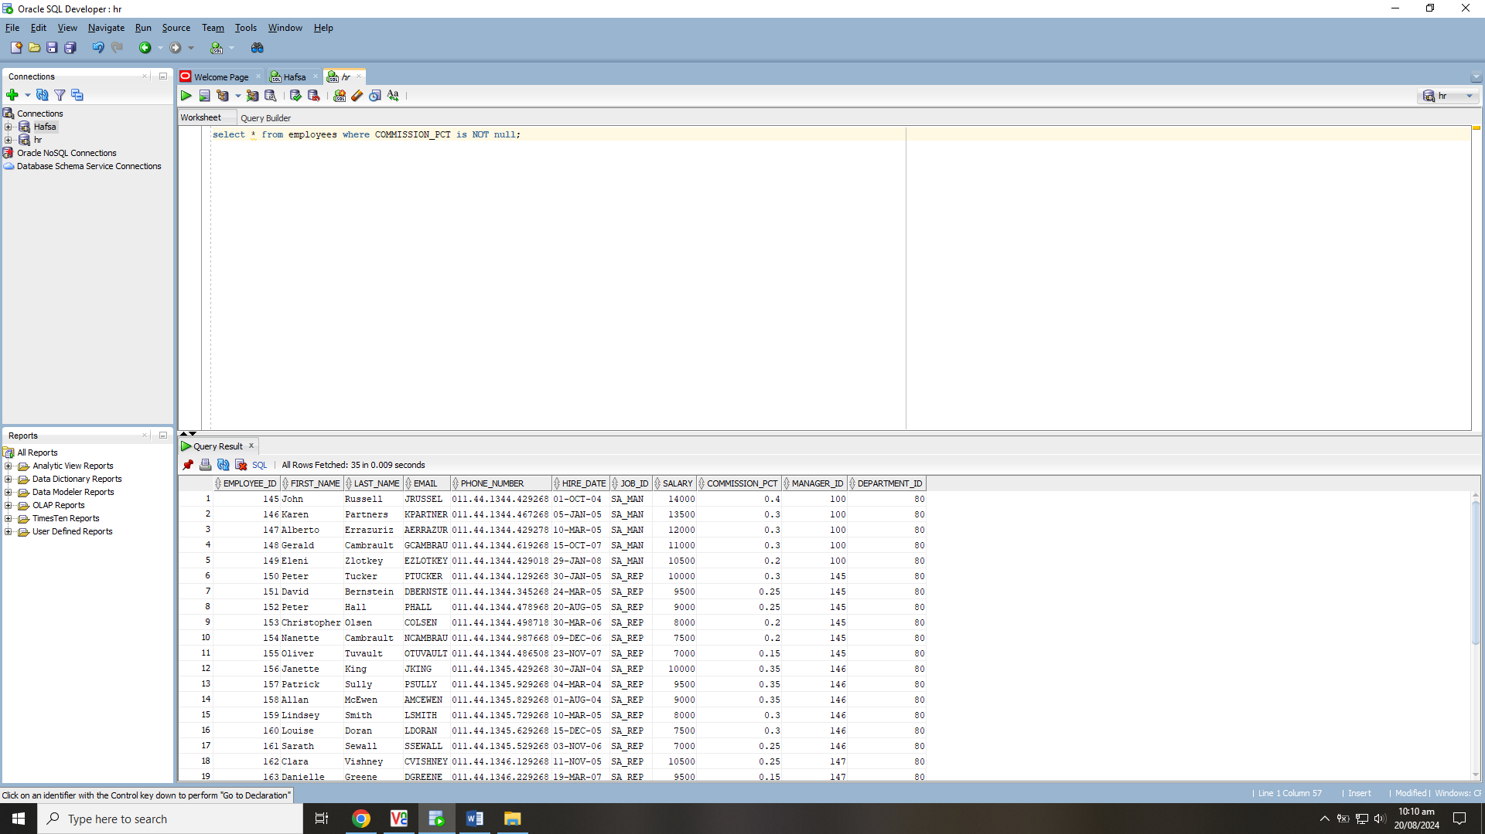

**Task no. 08**

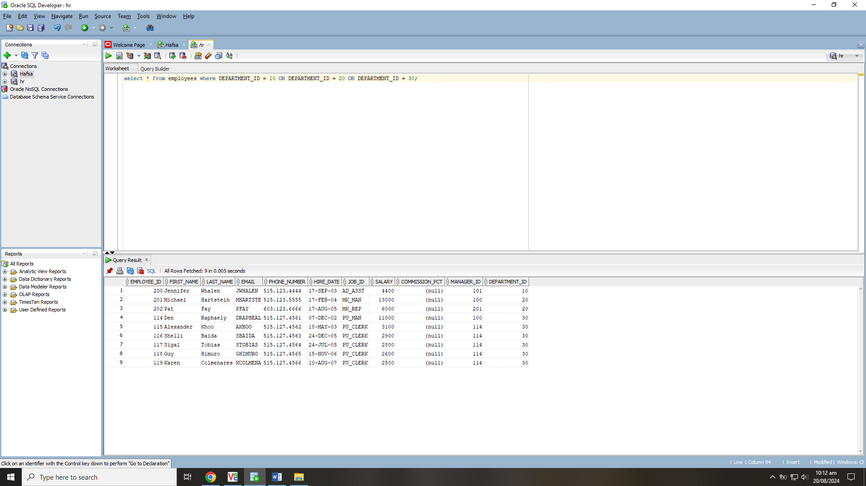

**Task no. 09**

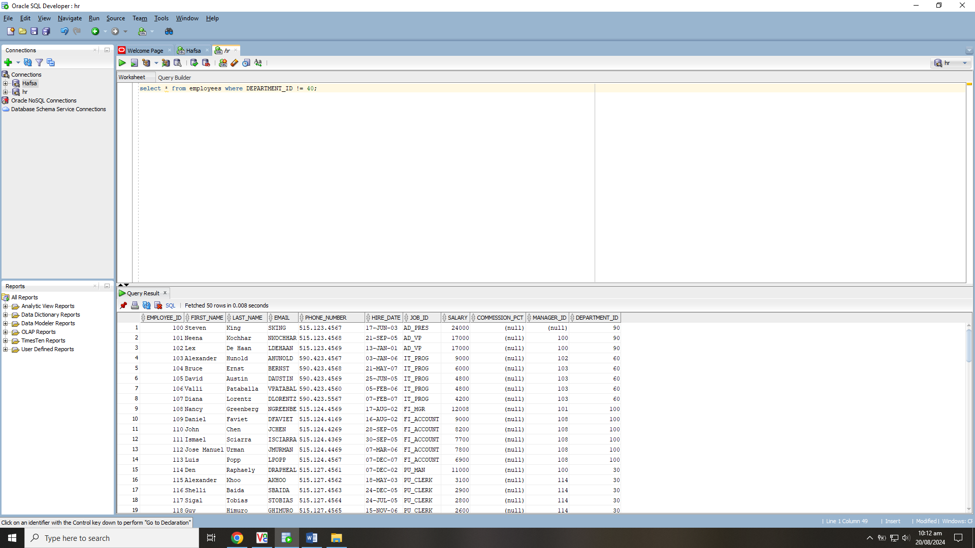

**Task no. 10**

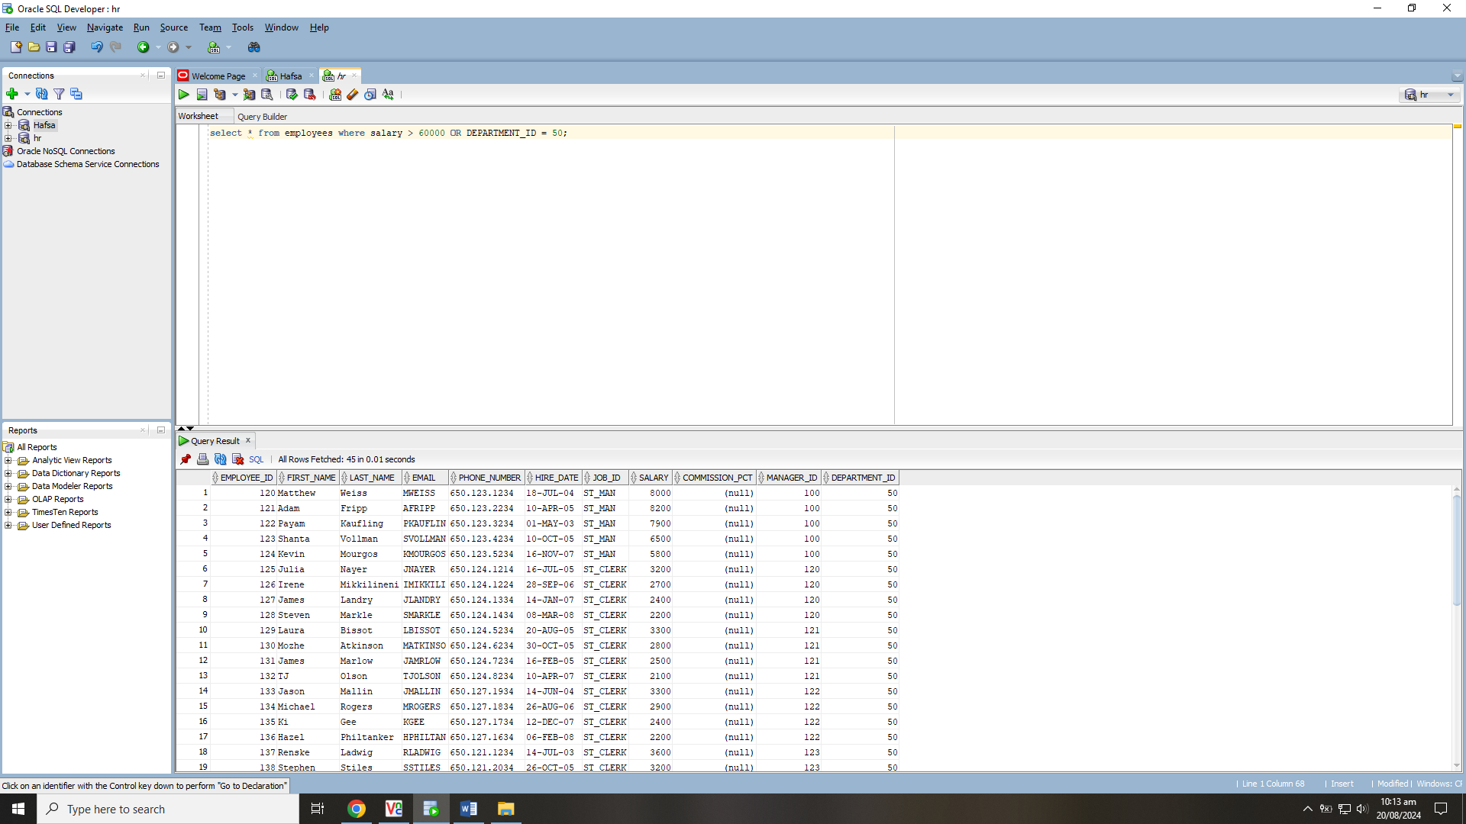

**Lab Task 01**

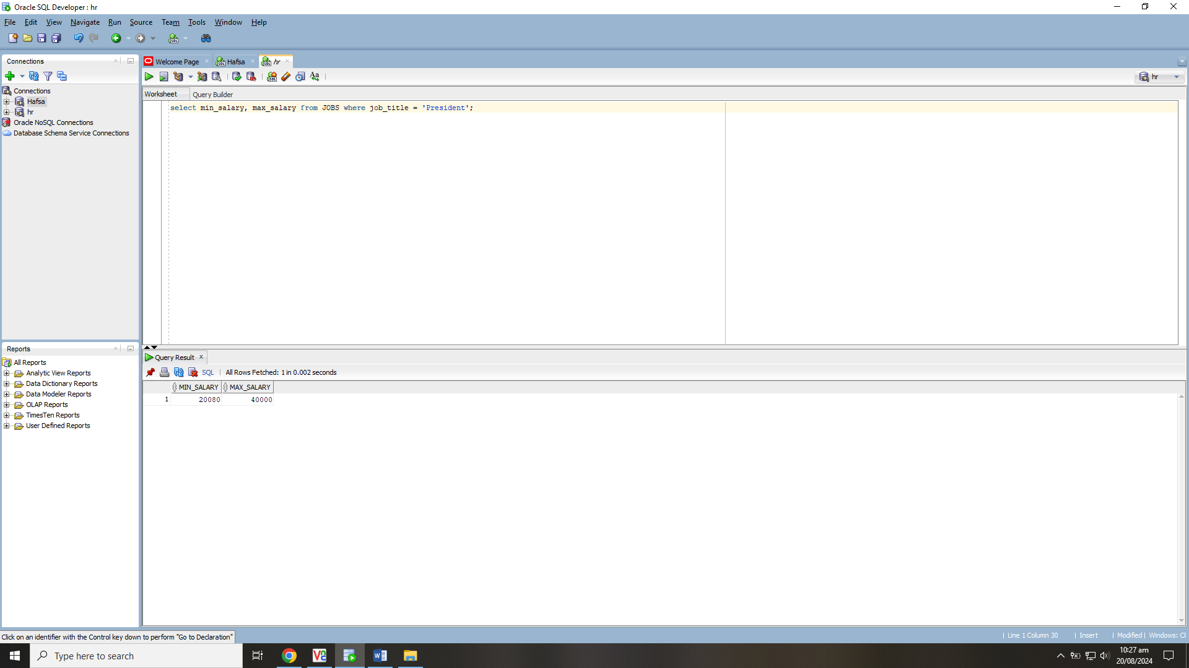

**Lab Task 02**

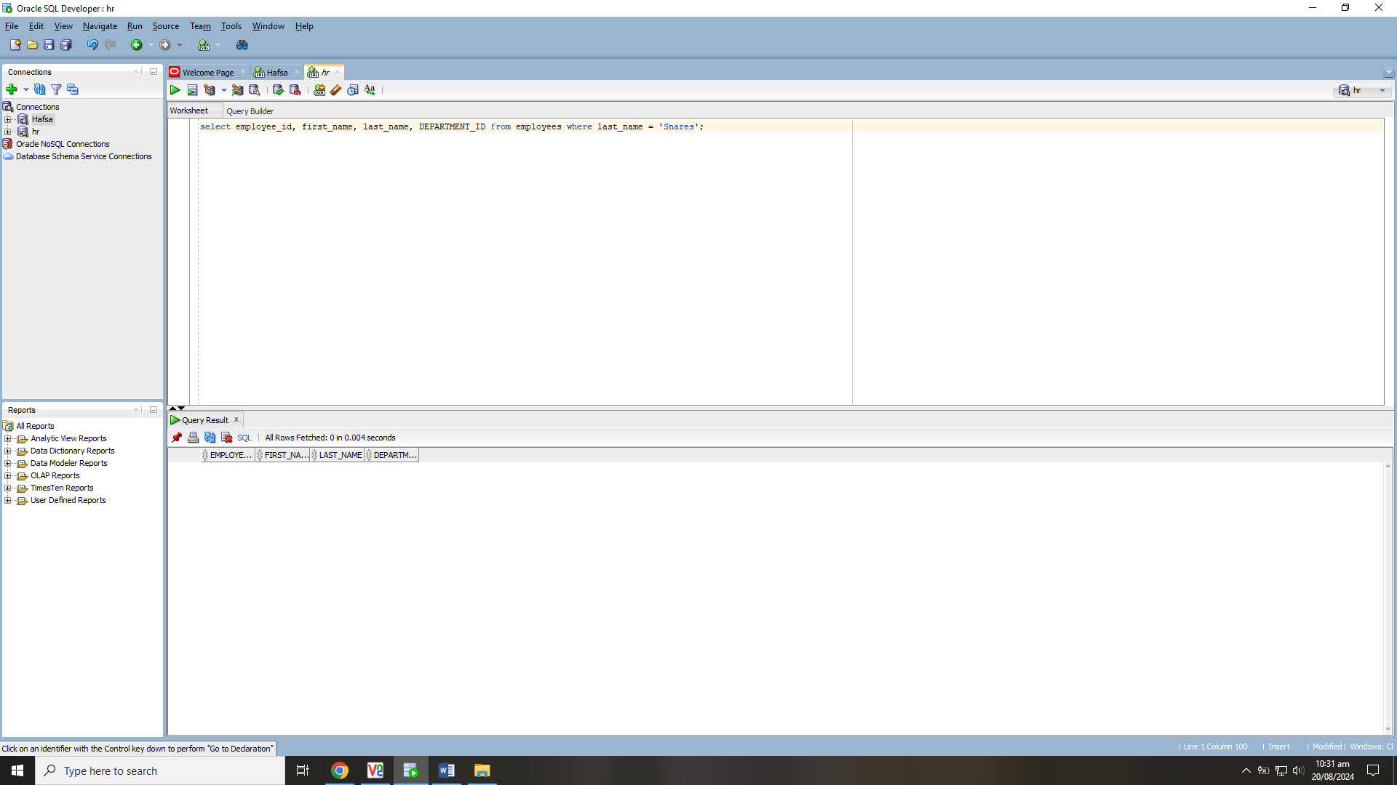

**Lab Task 03**

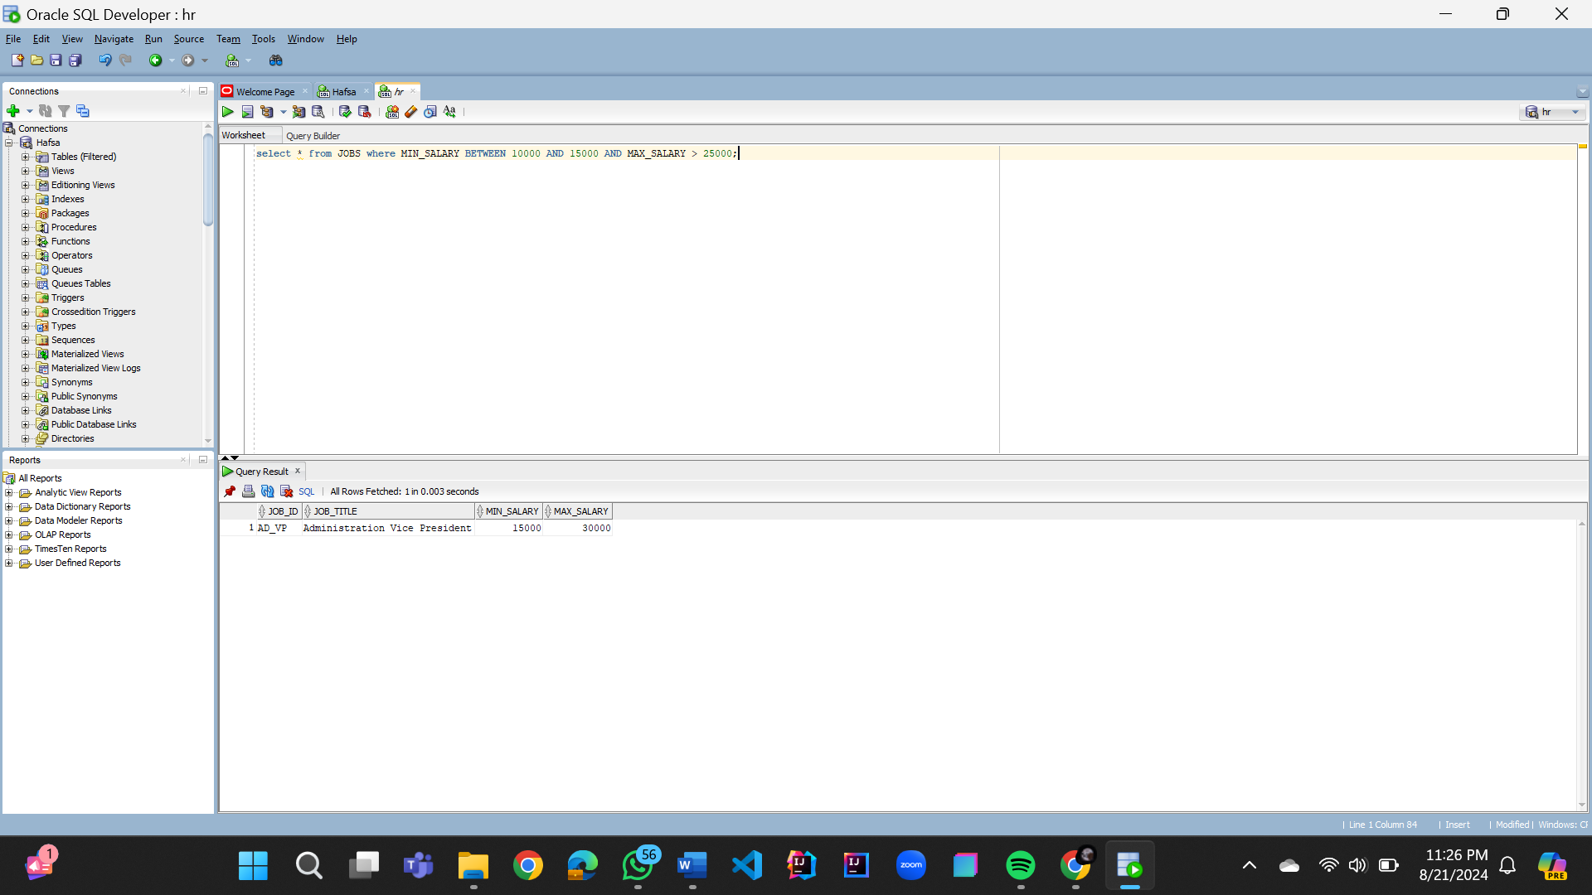

**Lab Task 04**

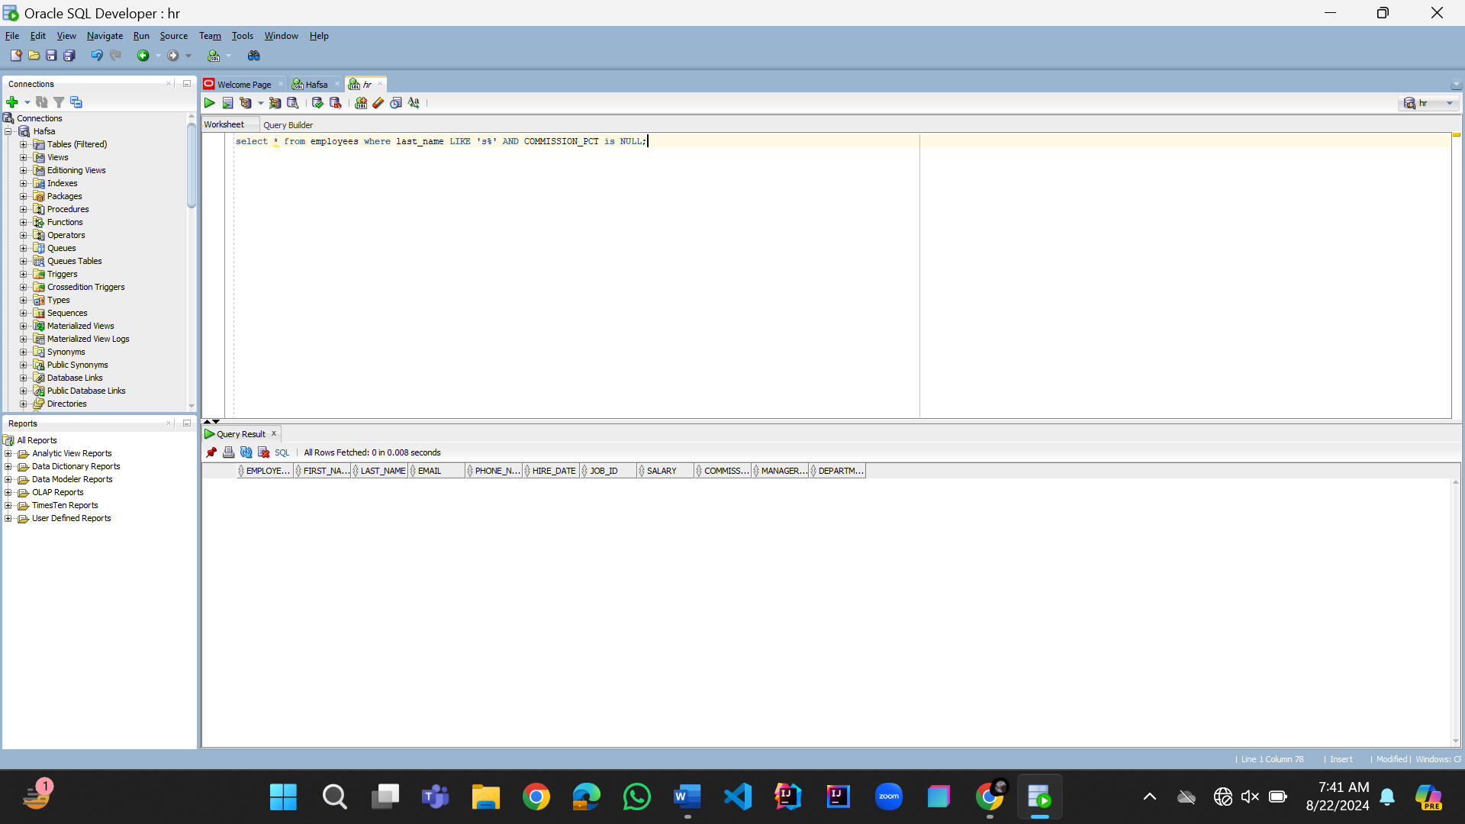

**Lab Task 05**

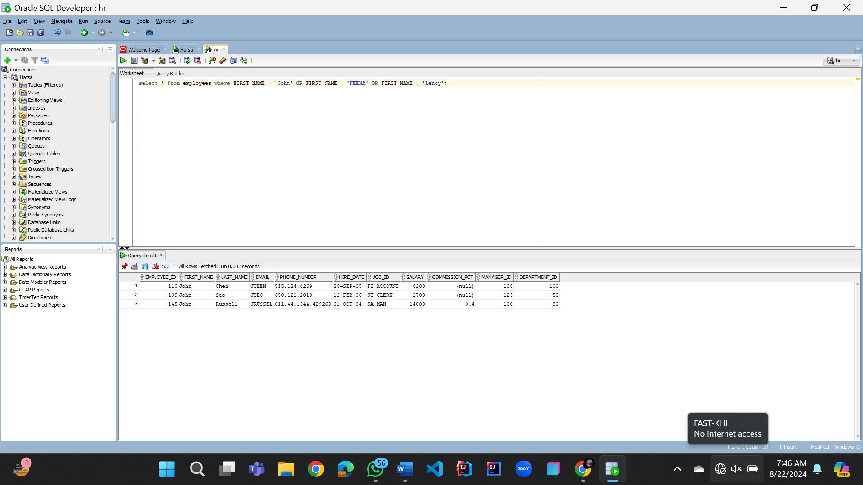

**Lab Task 06**

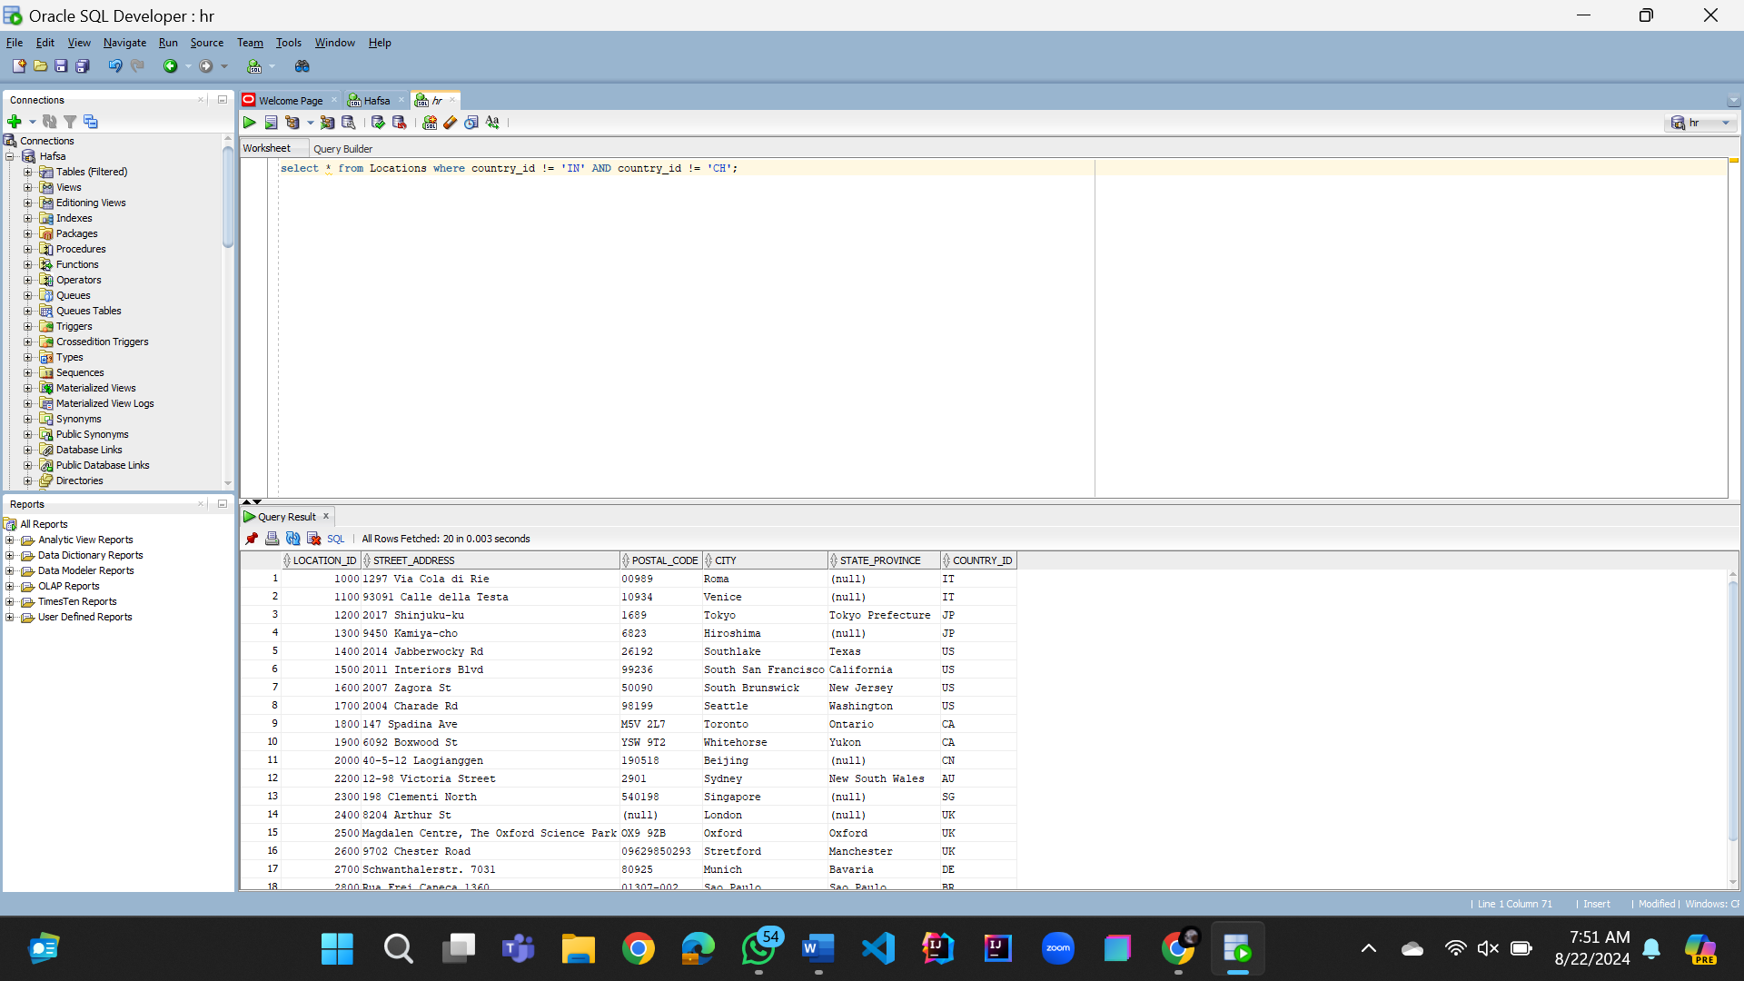

**Lab Task 07**

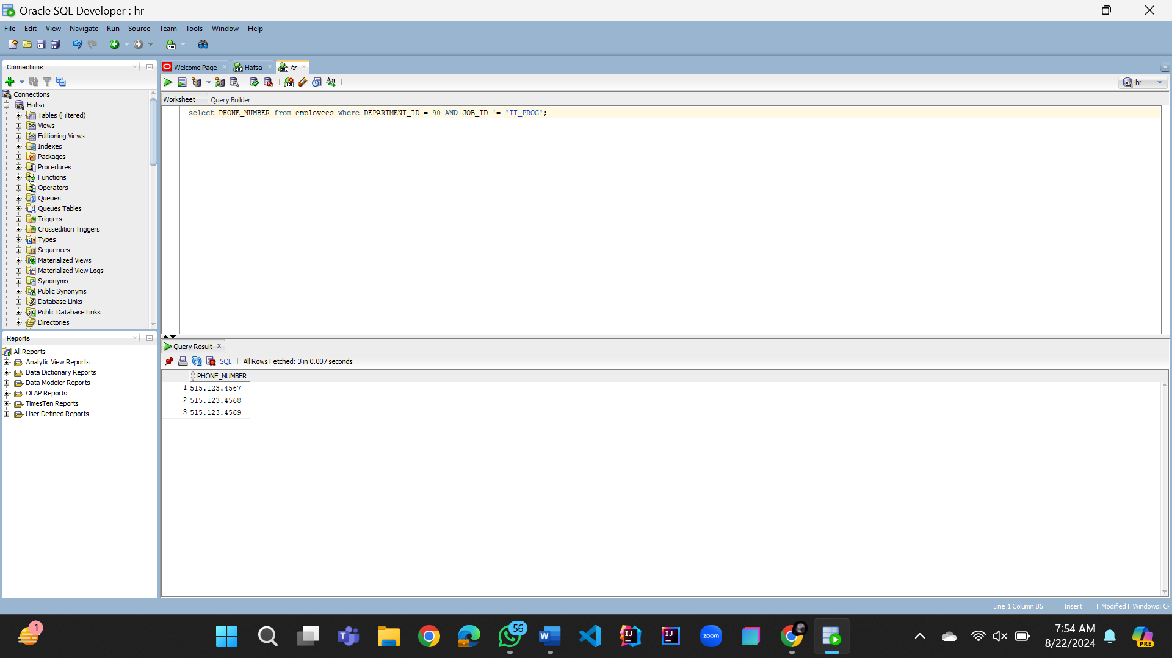

**Lab Task 08**

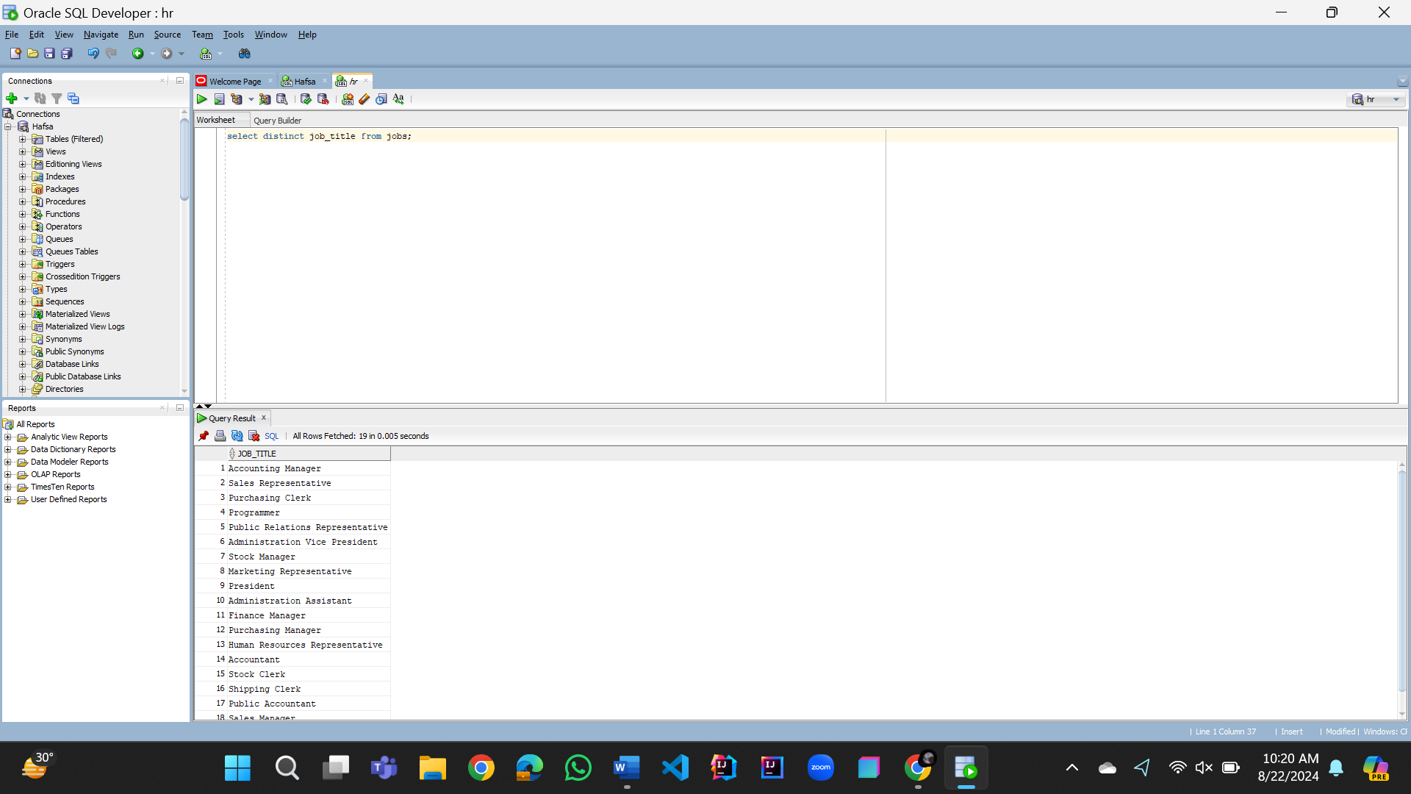

**Lab Task 09**

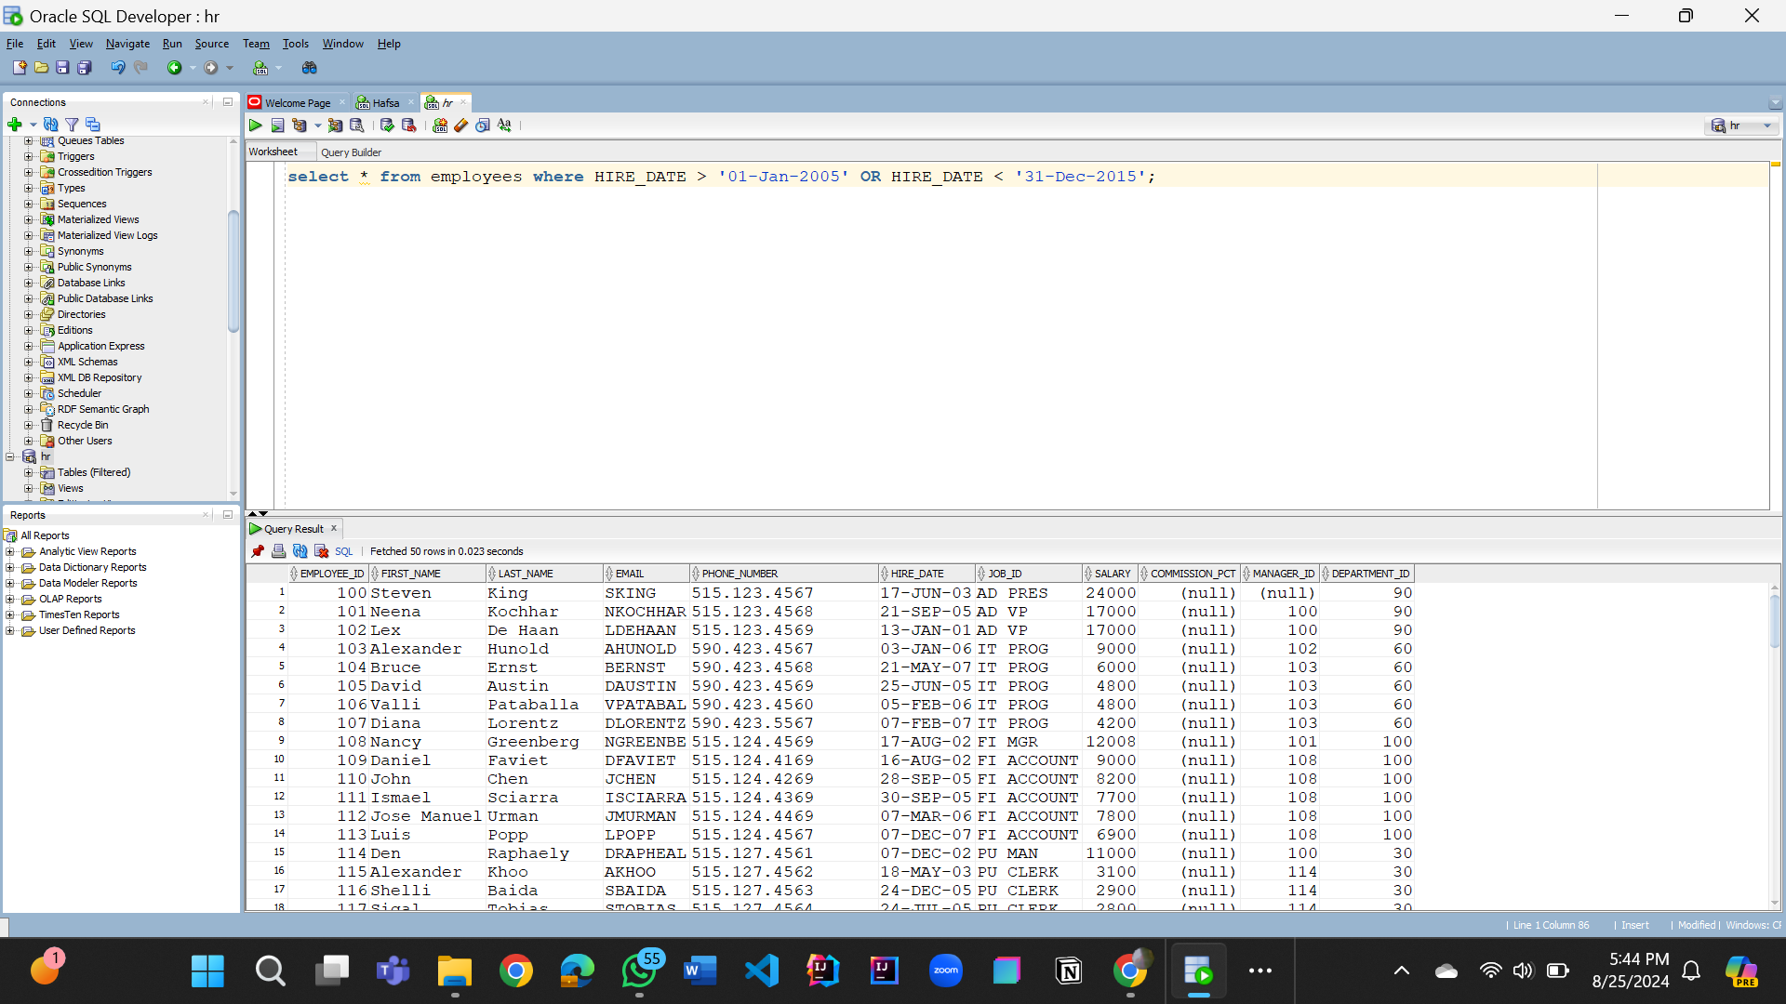

**Lab Task 10**

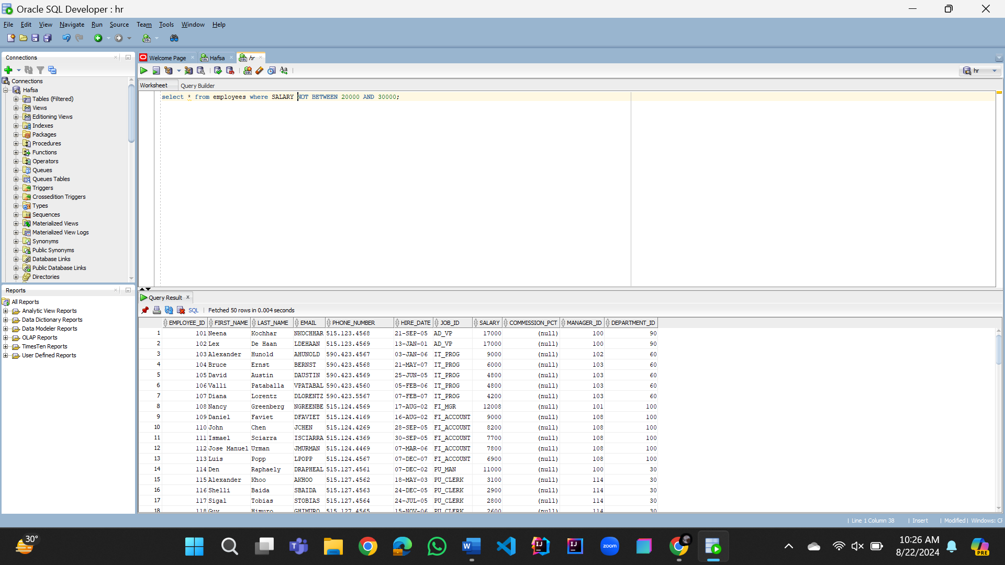

**Lab Task 11** (Same as 05)

**Lab Task 12**

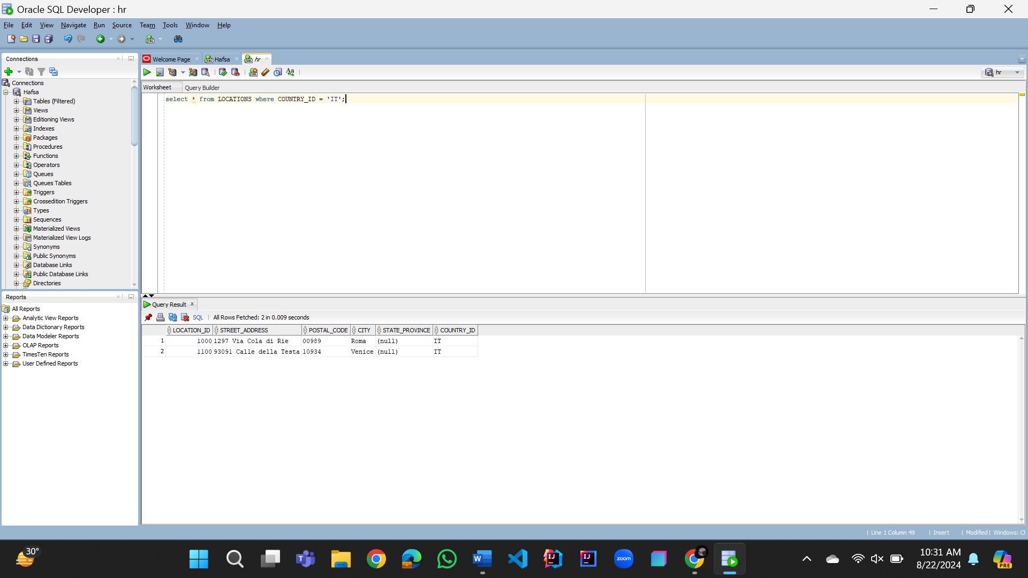

**Lab Task 13** (Same as Lab Task 06)



**Lab Task 14**

**Lab Task 15**

